E G S P ENGINEERING COLLEGE, NAGAPATTINAM

COMPUTER GRAPHICS

PART-A

- What are the two tables used in Scan-line method and give the content of those tables
(i) Edge table:
It contains
  - Coordinate endpoints for each line in the scene
  - Inverse sl;ope of each line
  - Pointers into the polygon table to identify the surfaces bounded by each line
(ii)Polygon table:
It contains
- Coefficients of the plane equation for each surface
- Intensity information for the surfaces
- Pointers into the edge table

- Mention the difference between parallel and perspective projection
In a parallel projection, coordinate positions are transformed to the view plane along parallel lines.
In perspective projection, object positions are transformed to the view plane along lines that converge to a point called the projection reference point(center of projection).

3. Define active list in visible surface detection method
It is a list of edges from information in the edges table. This list will contain only edges that cross the current scan line , sorted in order of increasing x.

- Define about projectors and centre of projection
Projectors:
Imaginary line between object & plane
Centre of projection:
A vanishing point (ie) converging point of all projectors

5. What bare the two approaches used for visible surface detection?
i) Object space method , ii) Image space method

PART B

6. a) Explain the following 3D transformation
(i) Rotation
(ii) Translation with scaling
(iii) Steps involved in a rotation about an arbitrary point

- Rotation

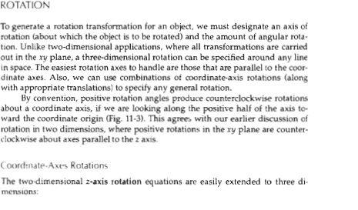
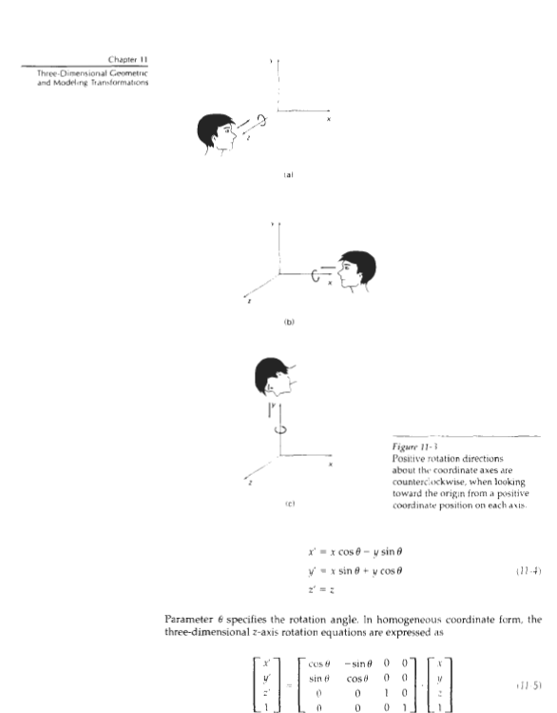

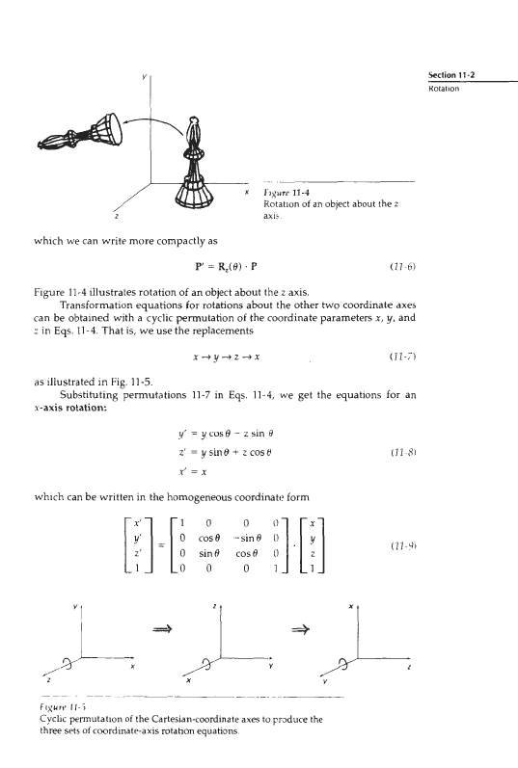
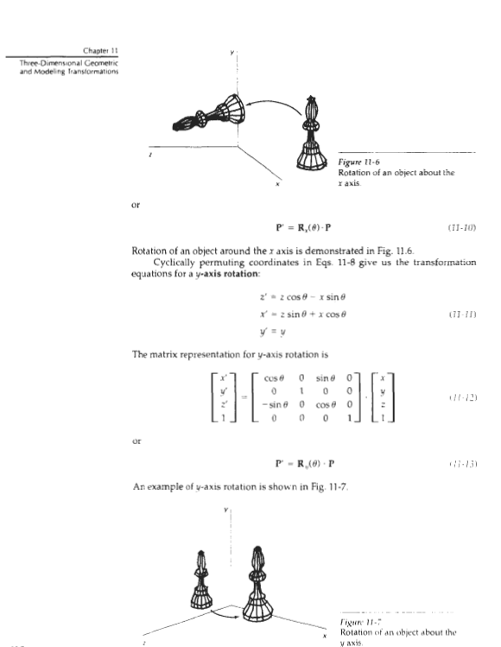

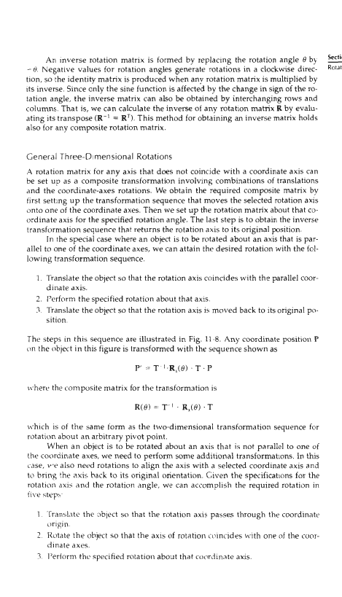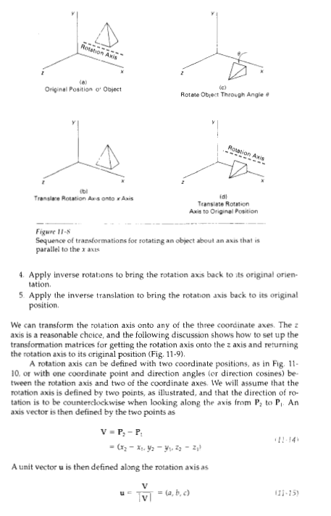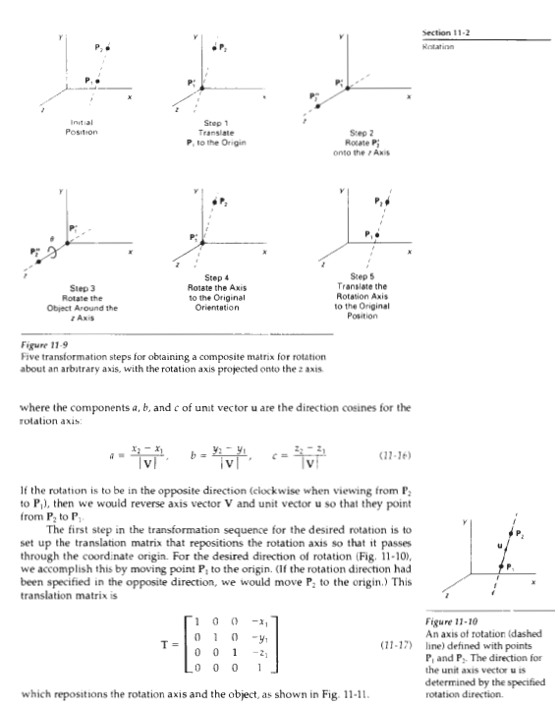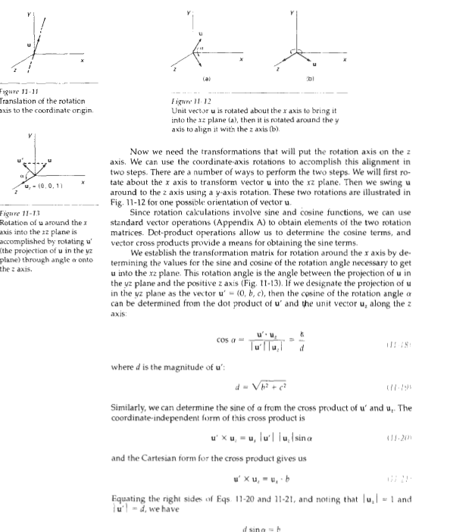

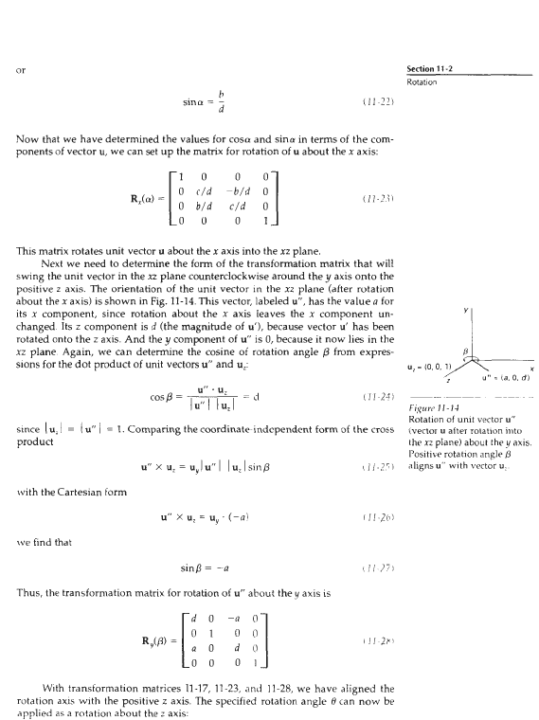

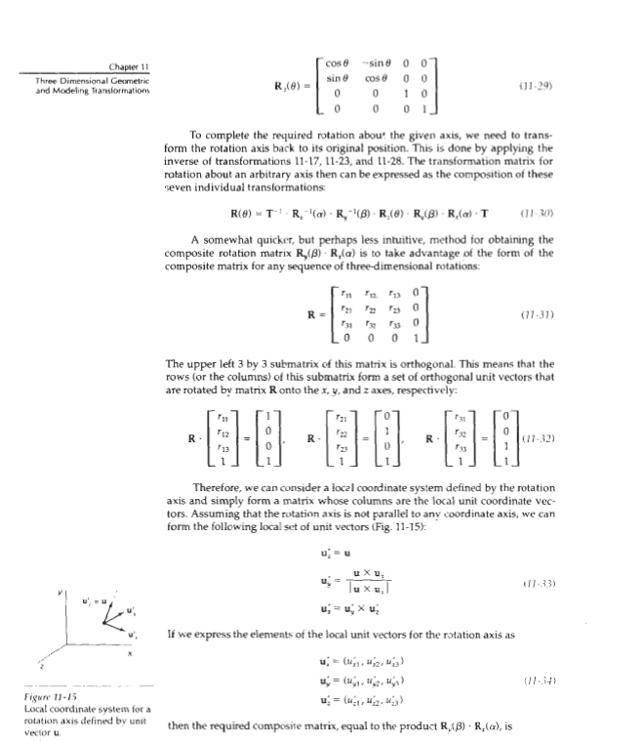

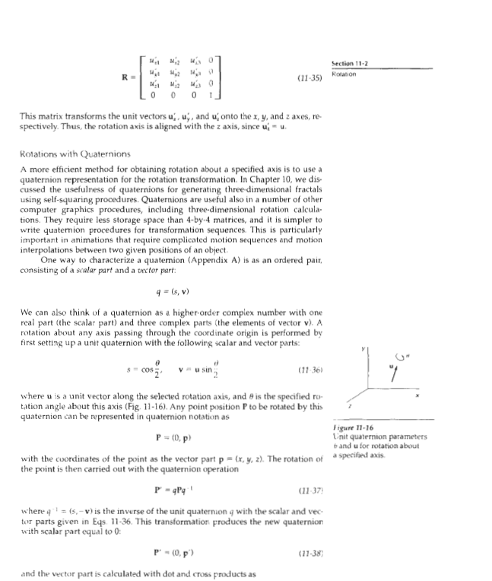

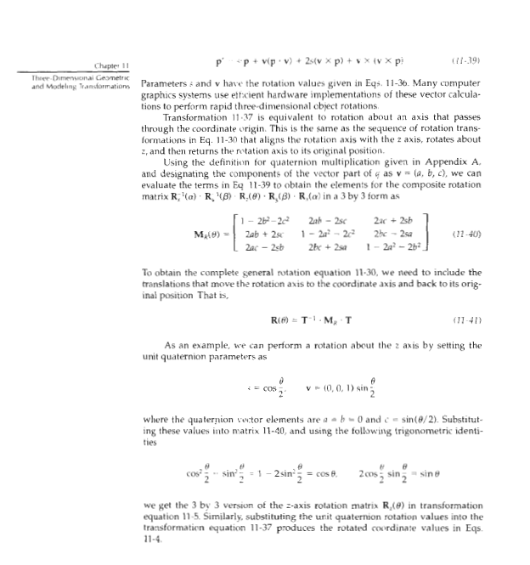

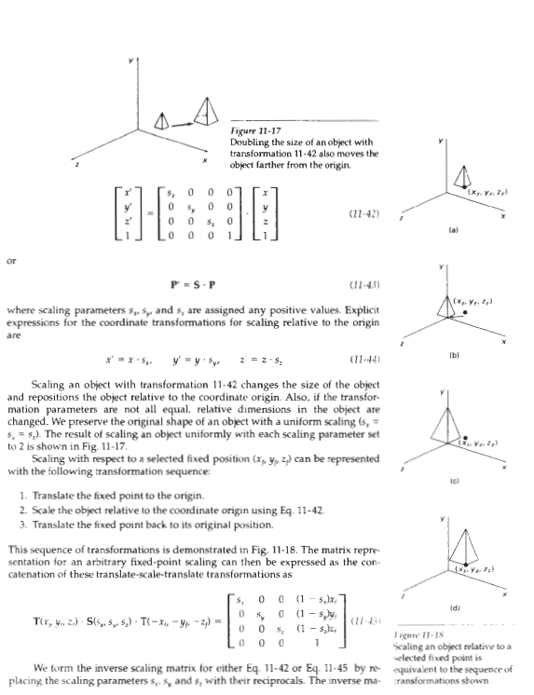

(iii) Steps involved in a rotation about an arbitrary point

- Translate the arbitrary point to the coordinate origin
- Do the rotation transformation
- Translate the point to the original position

(or)

b) Explain Z- Buffer method used in visible surface detection

DEPTH-BUFFER METHOD
A commonly used image-space approach to detecting visible surfaces is the
depth-buffer method, which compares surface depths at each pixel position on
the projection plane. This procedure is also referred to as the z-buffer method,
since object depth is usually measured from the view plane along the z axis of a
viewing system. Each surface of a scene is processed separately, one point at a
time across the surface. The method is usually applied to scenes containing only
polygon surfaces, because depth values can be computed very quickly and the
method is easy to implement. But the method can be applied to nonplanar surfaces.
With object descriptions converted to projection coordinates, each (x, y, 2 )
position on a polygon surface corresponds to the orthographic projection point
(x, y) on the view plane. Therefore, for each pixel position (x, y) on the view
plane, object depths can be compared by comparing z values. Figure 13-4 shows
three surfaces at varying distances along the orthographic projection line from
position (1,y ) in a view plane taken as the x ~ plane. Surface 5, is closest at this
position, so its surface intensity value at (x, y) is saved.
We can implement the depth-buffer algorithm in normalized coordinates,
so that z values range from 0 at the back clipping plane tn 7,,,, at the front clip
ping plane. The value of z, can be set either to 1 (for a unit cube) or to the
largest value that can be stored on the system.

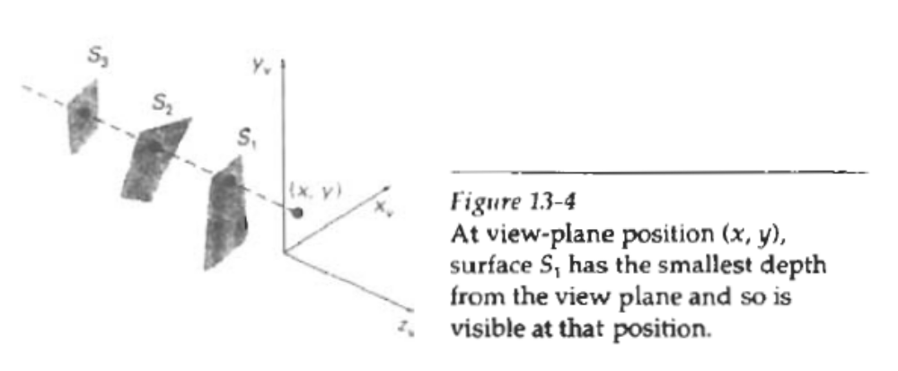

As implied by the name of this method, two buffer areas are required. A
depth buffer is used to store depth values for each (x, y) position as surfaces are
processed, and the refresh buffer stores the intensity values for each position. Initially,
all positions in the depth buffer are set to 0 (minimum depth), and the refresh
buffer is initialized to the background intensity. Each surface listed in the
polygon tables is then processed, one scan line at a time, calculating the depth (z value) at each (x, y) pixel position. The calculated depth is compared to the value
previously stored in the depth buffer at that position. If the calculated depth is
p a t e r than the value stored in the depth buffer, the new depth value is stored,
and the surface intensity at that position is determined and in the same xy
location in the refresh buffer.
We summarize the steps of a depth-buffer algorithm as follows:

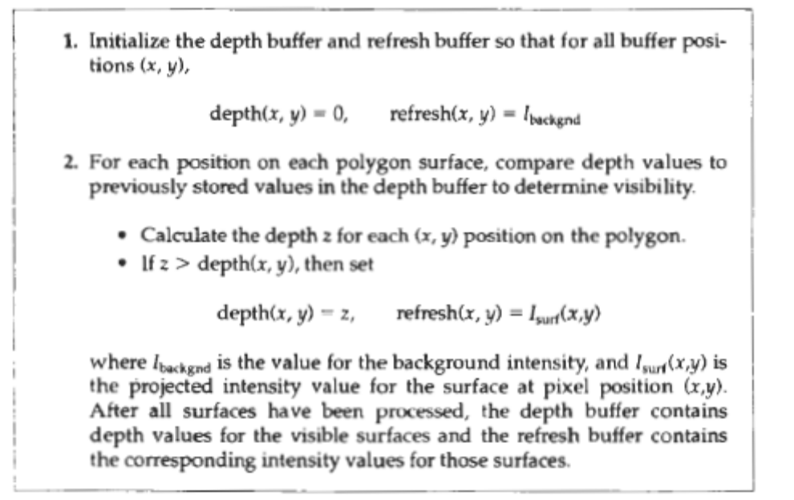

Depth values for a surface position (x, y) are calculated from the plane equation for each surface:
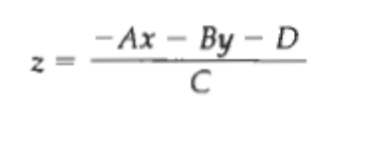
For any scan line (Fig. 13-5), adjacent horizontal positions across the line differ by 1, and a vertical y value on an adjacent scan line differs by 1. If the depth of position (x, y) has been determined to be z, then the depth z' of the next position (x +1, y) along the scan line is obtained from Eq. 13-4 as Y – 1 Figure 13-
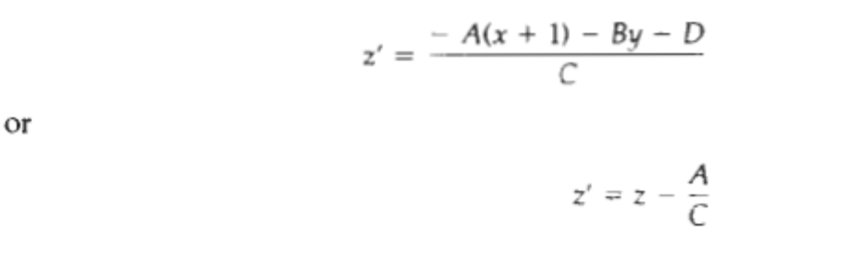
The ratio -A/C is constant for each surface, so succeeding depth values across a scan line are obtained from precrd~ngv alues with a single addition.On each scan line, we start by calculating the depth on a left edge of the polygon that intersects that scan line (Fig. 13-6). Depth values at each successive position across the scan line are then calculated by Eq. 13-6.We first determine the y-coordinate extents of each polygon, and process the surface from the topmost scan line to the bottom scan line, as shown in Fig.13-6. Starting at a top vertex, we can recursively calculate x positions down a left edge of the polygon as x' = x - l/m, where rn is the slope of the edge (Fig. 13-7). Depth values down the edge are then obtained recursively as
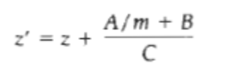
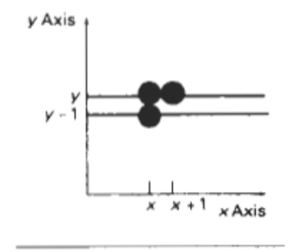 From position (x, y) on a scan line, the next position across the line has coordinates ( X + 1, y), and the position immediately below on the next line has coordinates (1, y - 1).
If we are processing down a vertical edge, the slope is infinite and the recursive calculations reduce to
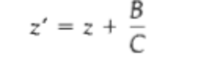
An alternate approach is to use a midpoint method or Bresenham-type algorithm
for determining x values on left edges for each scan line. Also the method can be applied to curved surfaces by determining depth and intensity values at each surface projection point.
For polygon surfaces, the depth-buffer method is very easy to impjement, and it requires no sorting of the surfaces in a scene. But it does require the availability of a second buffer in addition to the refresh buffer. A system with a resolution

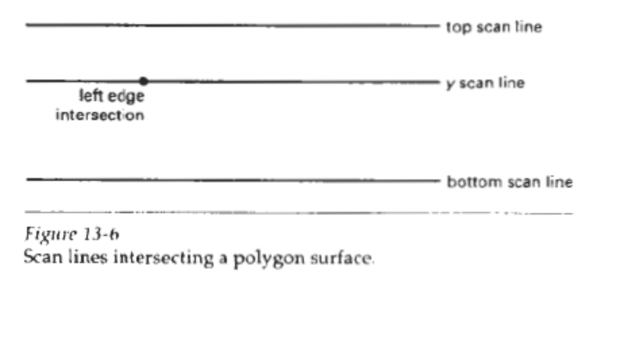
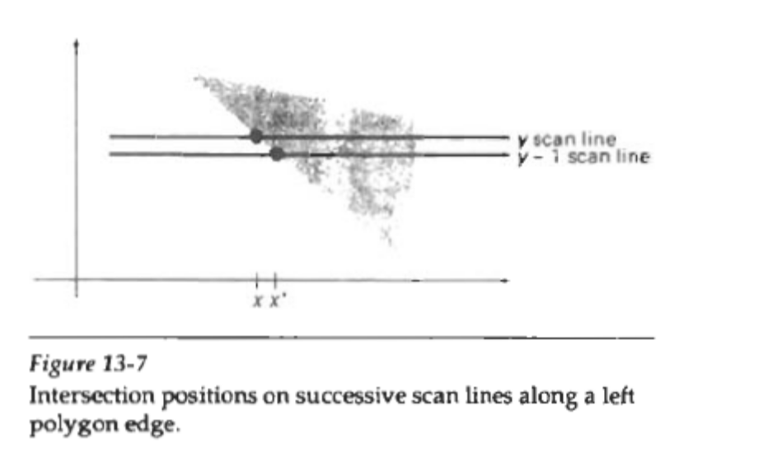
of 1024 by 1024, for example, would require over a million positions in the depth buffer, with each position containing enough bits to represent the number of depth increments needed. One way to reduce storage requirements is to process one section of the scene at a time, using a smaller depth buffer. After each view section is processed, the buffer is reused for the next section.

7. a) (i) Explain about Orthographic projection and its various types 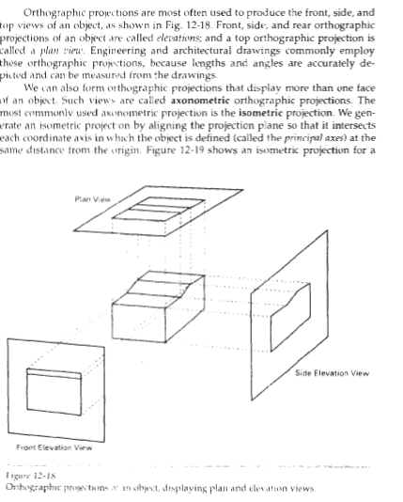 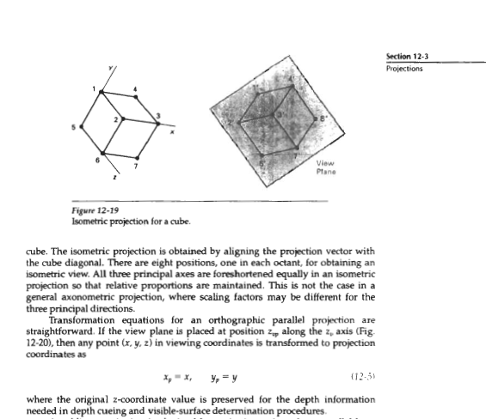

(ii) Explain about Backface detection algorithm used for visible
surface detection

BACK-FACE DETECTION
A fast and simple object-space method for identifying the back faces of a polyhe
dron is based on the "inside-outside" tests discussed in Chapter 10. A point (x, y,
z) is "inside" a polygon surface with plane parameters A, B, C, and D if
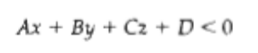
When an inside point is along the line of sight to the surface, the polygon must
be a back face (we are inside that face and cannot see the front of it from our
viewing position).
We can simplify this test by considering the normal vector N to a polygon
surface, which has Cartesian components (A, B, C). In general, if V is a vector in
the viewing direction from the eye (or "camera") position, as shown in Fig. 13-1,
then this polygon is a back face if

Furthermore, if object descriptions have been converted to projection coordinates
and our viewing direction is parallel to the viewing z,. axis, then V = (0, 0, V;)
and
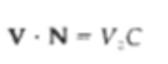
so that we only need to consider the sign of C, the ; component of the normal
vector N
In a right-handed viewing system with viewing direction along the negative
z,, axis (Fig. 13-21, the polygon is a back face if C < 0. Also, we cannot see any
Face whose normal has z component C ..- 0, since our viewing direction is grazing
That polygon. Thus, in general, we can label any polygon as a back face if its normal
Vector has a z component value:
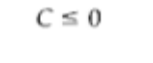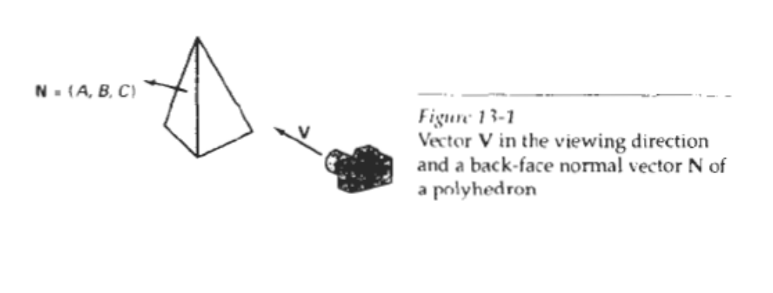
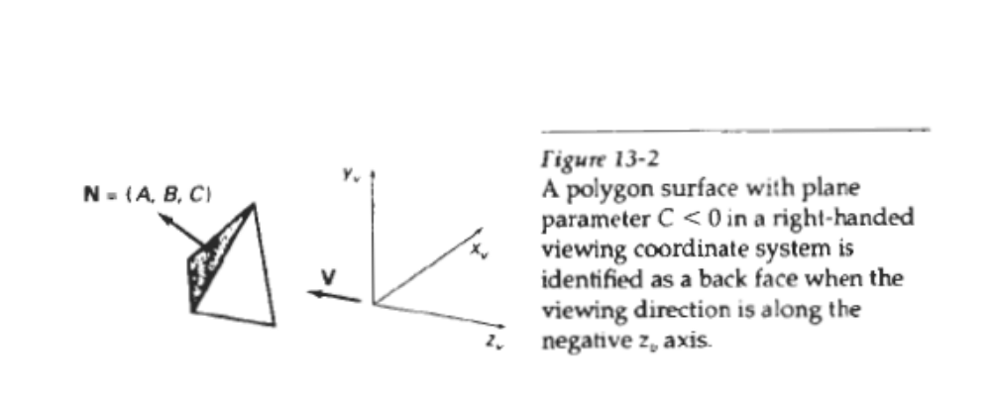
Similar methods can be used in packages that employ a left-handed viewing
system. In these packages, plane parameters A, B, C: and D can be calculated
from polygon vertex coordinates specified in a clockwise direction (instead of the
counterclockwise direction used in a right-handed system). Inequality 13-1 then
remains a valid test for inside points. Also, back faces have normal vectors that
point away from the viewing position and are identified by C 2 0 when the
viewing direction is along the positive z, axis.
By examining parameter C for the different planes defining an object, we
can immed~atelyid entify all the back faces. For a single convex polyhedron, such
as the pyramid in Fig. 13-2, this test identifies all the hidden surfaces on the object,
since each surface is either completely visible or completely hidden. Also, if
a scene contains only nonoverlapping convex polyhedra, then again all hidden
surfaces are identified with the back-face method.
For other objects, such as the concave polyhedron in Fig. 13-3, more tests
need to be carried out to determine whether there are additional faces that are to-
Figure 13-3 tally or partly obscured by other faces. And a general scene can be expected to
View of a concave contain overlapping objects along the line of sight. We then need to determine
polyhedron with one face where the obscured objects are partially or comp1etel.y hidden by other objects. In
partially hidden by other general, back-face removal can be expected to eliminate about half of the polygon
faces. surfaces in a scene from further visibility tests.
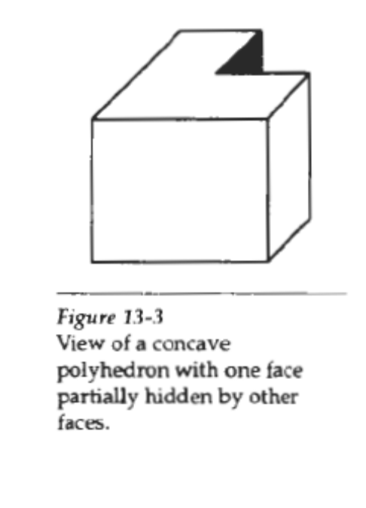
(or)

b) (i) Explain Scanline method in detail

SCAN-LINE METHOD
This imagespace method for removing hidden surface5 is an extension of the
scan-linealg&ithni for tilling polygon interiors. Instead of filling just one surface,
we now deal with multiple surfaces. As each scan line is processed, all polygon
surfaces intersecting that line are examined to determine which are visible.
Across each scan line, d ~ p t hca lculations are made for each overlapping surface
to determine which is nearest to the view plane. When the visible surface has
been determined, the mtensity value for that position is entered into the refresh
buffer.
We assume that tables are-set up for the various surfaces, as discussed in
Chapter 10, which include both an edge table and a polygon table. The edge table
contains coordinate endpoints for each line in-the scene, the inverse slope of each
line, and pointers into the polygon table to identify the surfaces bounded by each
line. The polygon table contains coefficients of the plane equation for each surface, intensity information for the surfaces, and possibly pointers into the edge
table. To facilitate the search for surfaces crossinga @ven scan line, we can set up
an active list of edges from information in the edge table. This active list will contain
only edges that cross the current scan line, sorted in order of increasing x. In
addition, we define a flag for each surface that is set on or off to indicate whether
a position along a scan line is inside or outside of the surface. Scan lines are
processed from left to right. At the leftmost boundary of a surface, the surface
flag is turned on; and at the rightmost boundary, it is turned off.
Figure 13-10 illustrates the scan-line method for locating visible portions of
surfaces for pixel positions along the line. The active list for &an line 1 contains
information from the edge table for edges AB, BC, EH, and FG. For positions
along this scan line between edges AB and BC, only the flag for surface Sl is on.
Therefo~n, o depth calculations are necessary, and intensity information for surface
S, is entered from the polygon table into the refresh buffer. Similarly, between
edges EH and FG, only the flag for surface S2 is on. NO other positions
along scan line 1 intersect surfaces, so the intensity values in the other areas are
set to the background intensity. The background intensity can be loaded throughout
the buffer in an initialization routine.
For scan lines 2 and 3 in Fig. 13-10, the active edge l~scto ntains edges AD,
EH, BC, and FG. Along scan line 2 from edge AD to edge EH, only the flag for
surface S, is on. But between edges EH and BC, the flags for both surfaces are on.
In this interval, depth calculations must be made using the plane coefficients for
the two surfaces. For this example, the depth of surface SI is assumed to be less
than that of S,, so intensities for surface S, are loaded into the refresh buffer until
boundary BC is encountered. Then the flag for surface SI goes off, and intensities
for surface S2 are stored until edge FG is passed.
We can take advantage of-coherence along the scan lines as we pass from
one scan line to the next. In Fig. 13-10, scan line 3 has the same active list of edges
as scan line 2. Since no changes have occurred in line intersections, it is unnecessary
again to make depth calculations between edges EH and BC. The two surfaces must be in the same orientation as determined on scan line 2, so the intensities
for surface S, can be entered without further calculations.
Any number of overlapping polygon surfaces can be processed with this
scan-line method. Flags for the surfaces are set to indicate whether a position is
inside or outside, and depth calculations are performed when surfaces overlap.
When these coherence methods are used, we need to be careful to keep track of
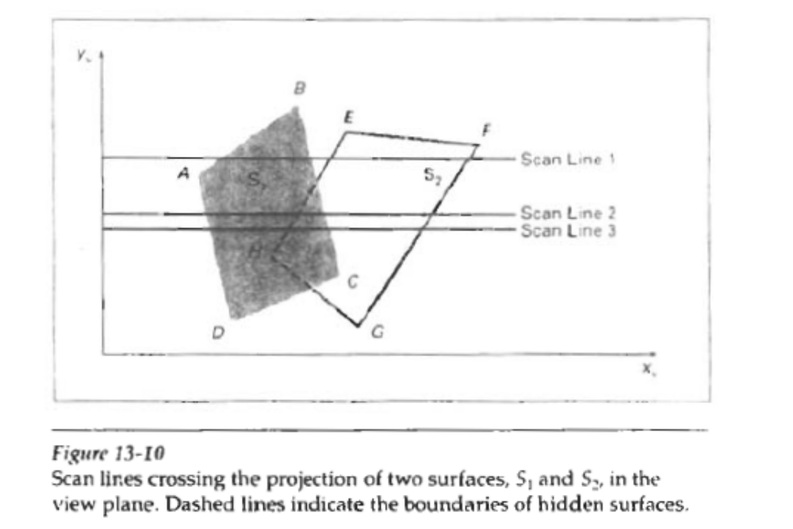

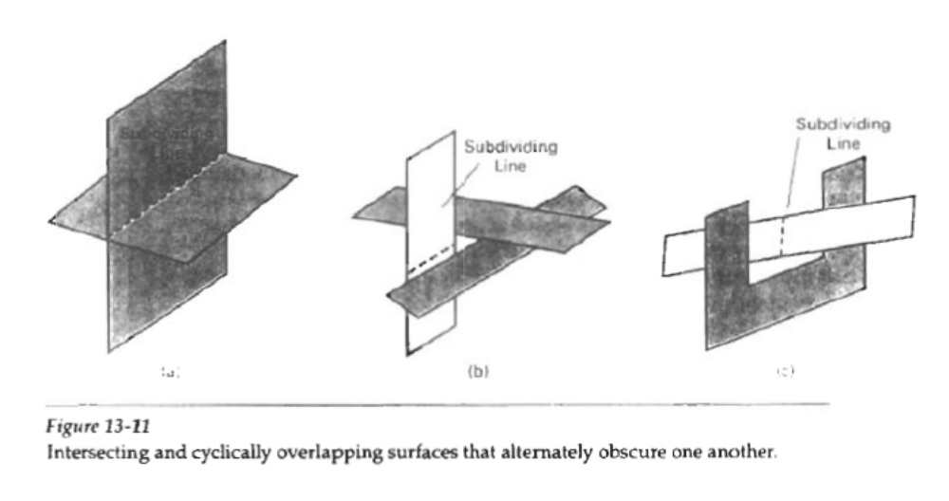
which surface section is visible on each scan line. This works only if surfaces do
not cut through or otherwise cyclically overlap each other (Fig. 13-11). If any kind
of cyclic overlap is present in a scene, we can divide the surfaces to eliminate the
overlaps. The dashed lines in this figure indicate where planes could be subdivided
to form two distinct surfaces, so that the cyclic overlaps are eliminated.

(ii) Explain Oblique projection

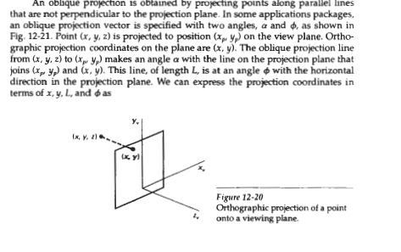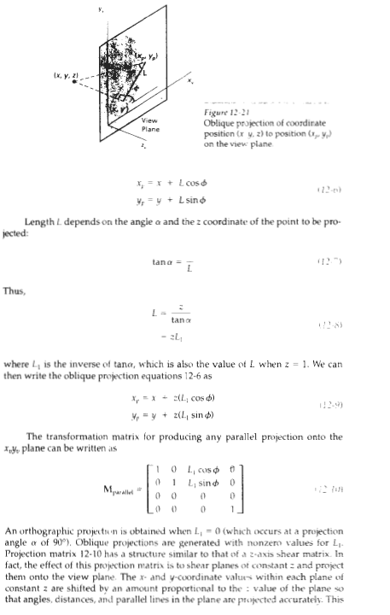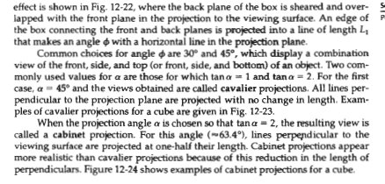

8. a) Explain the 3D viewing pipeline operations

3D viewing pipeline 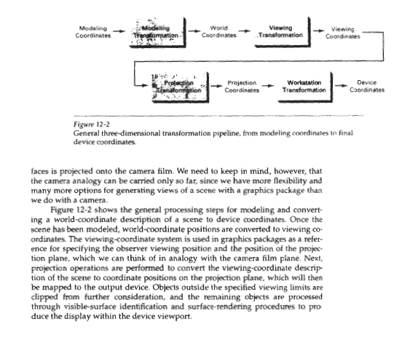

(or)

b) (i) Describe the theory and taxonomy of projection

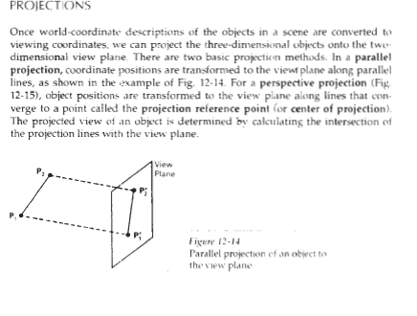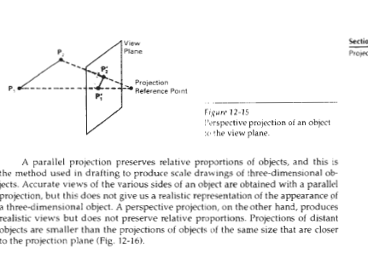
(ii) Compare parallel and perspective projection


